Nama : Muhammad Reza Adi Wardana
Kelas : 22 RPL B
NIM : 2022010018
TUGAS 5
Hasil :
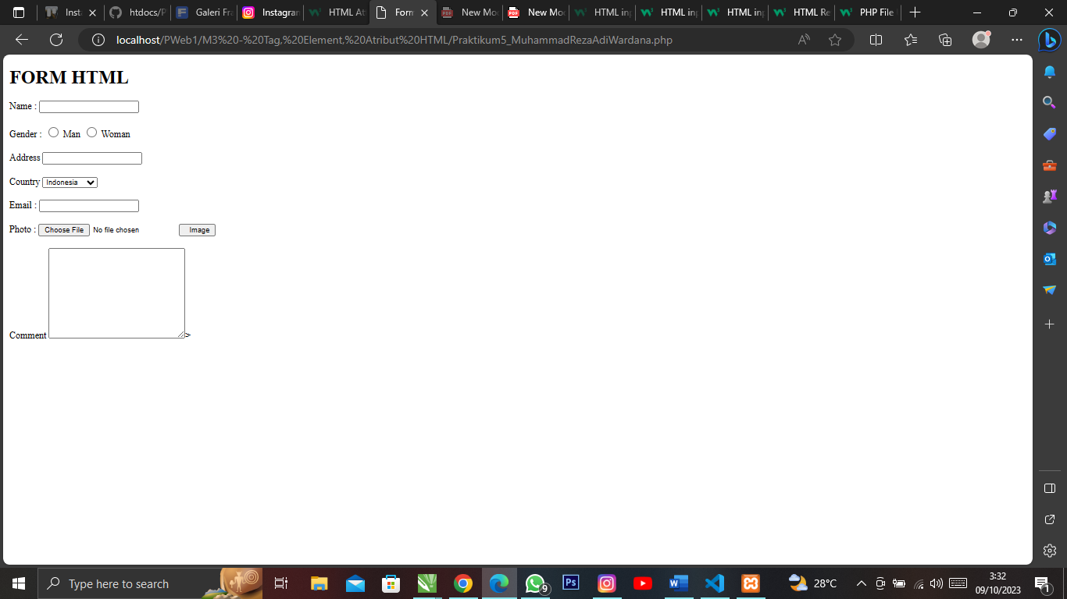

Sourcode :
<!DOCTYPE html>
<html lang="en">
<head>
<meta charset="UTF-8">
<meta name="viewport" content="width=device-width, initial-scale=1.0">
<title>Form</title>
</head>
<body>
<h1>FORM HTML</h1>

<label for="nama">Name :</label>
<input type="text" id="nama"><br>
<br>

<label for="">Gender :</label>
<input type="radio" id="man" >
<label for="man">Man</label>
<input type="radio" id="woman">
<label for="woman">Woman</label><br>
<br>

<label for="address">Address</label>
<input type="text"id="address"><br>
<br>

<label for="country">Country</label>
<select name="country" id="country">
<option value="1">Indonesia</option>
<option value="2">Malaysia</option>
<option value="3">Singapore</option>
<option value="4">Timor Leste</option>
<option value="5">Brunei</option>
<option value="6">Australia</option>
</select><br>
<br>

<label for="email">Email :</label>
<input type="text" id="email"><br>
<br>

<label for="fileToUpload">Photo :</label>
<input type="file" name="fileToUpload" id="fileToUpload" >
<input type="submit" value=" Image" name="submit"><br>
<br>
<label for="coment">Comment</label>
<textarea name="coment" id="" cols="30" rows="10"></textarea>>
</body>
</html>

